FEATURES OF STRUCTURED AERO MIXTURES PROCESSES in pneumatic Transport pipeline based on the synergistic concept

Guschin O., Cherneckaya-Вeleckaya N.
Volodymyr Dahl East Ukrainian National University

The new conceptual approach to the study of the processes in the pneumatic pipeline, considered as an open system, submitted to the general laws of synergy, enables us to justify the phenomenon of self-regulation and self-transference of mass transfer in the material wire. Movement of homogeneous and heterogeneous flows is presented as a process of self-organization of collective bonds, determining the effective coefficients of impulse, power and mass transfer. In this case the regulation is carried out through the control parameters, which are taken as the Reynolds number, the Froude number, the Raleigh number and the Taylor number. Investigation of the processes occurring in pneumatic conveying of bulk materials is advisable to carry out on the basis of a common approach to the problem of predictability, based on the idea of partially determinate processes that allow dynamic prediction for limited time intervals.
The motion of the gas material flow in the pneumatic pipeline, which is equipped by an additional air duct, is being analyzed (Fig.1).

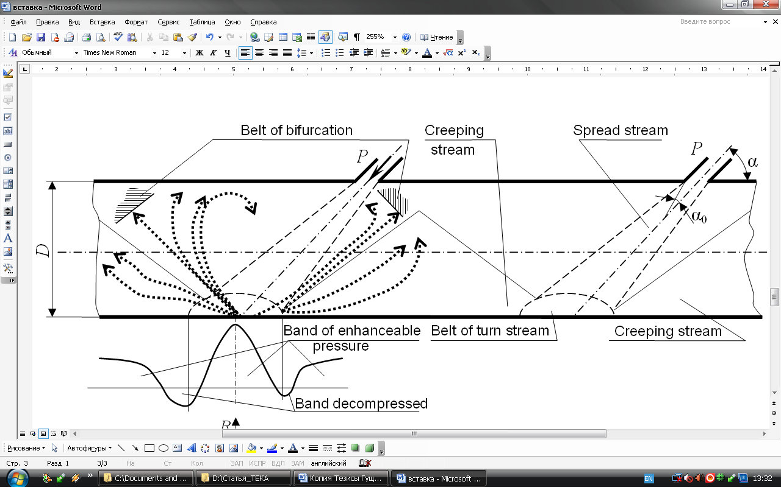
Fig.1. The scheme of formation of vortex structures with the emergence of bifurcation zone in pneumatic transport pipeline

Considering the formation of vortices creeping stream in the general movement direction, it is noticed that the direction of the vortices in the transition from the bottom surface to the top surface passes through the unstable vortex area. In certain place the vortices are being developed in opposite directions. A similar picture occurs in the creeping stream with backward direction. The direction of each vortex in this area can be modified without making significant changes in the geometric dimensions of the pipeline and dynamic flow properties. Therefore, the direction of vortices motion in this area can be regarded as equiprobable. From the point of view of the theory of dynamical systems, this transition is the bifurcation between two states: a state of rest and "convective" state.
The formation of individual vortices and the system is being analyzed. The appearance of the vortex embryo in the local area is defined as "attracting set." Therefore, all of the local fluctuation originated areas should be taken as the future vortices growth centers. Further growth and dynamics of these areas are defined by the substance flow of the external environment. Accepting the hypothesis of elementary volumes heritage, the growth of the vortex as a whole can be explained. With the growth of the vortex the process of the so-called “swelling” of vortex embryo area takes place, which carries self-similarity in a short period of time, and it makes it possible to describe this fact as a fractal structure with a certain rational dimension. If the basic time "sticking" is denoted by τ, the desired dimension can be estimated not geometrically, but as the Hausdorf dimension.
From the point of view of I.Prigogin, when the system evolves and reaches the point of bifurcation, the fluctuation causes the system to choose the branch, where the further evolution of the system will take place. Similarly is being carried the scheme of vortex structures formation with the emergence of bifurcation areas in the pneumatic transport pipeline with the structured aero mixtures movement modes.
For the autonomous independent of time system is valid
, (1)
where – vector with projections, X₁, X₂ … X_{N}, f_{i} – function evidently not dependent on time, λ – the quantity describing the internal and external system conditions.
Among the system solutions (1) there occur the solutions describing the stationary states
. (2)
The solution of system (1) are the points in the stationary phase space. Dividing the left and the right sides of the system (1) when i ≠ 1 in equation (2) for i=1 results
. (3)
The solution of the equation system (3) gives the phase trajectory in space. Changing the parameters λ in equation (1) causes the nature of the decisions change. There appear (disappear), new particular points. Stable particular points become unstable, and vice versa, etc. At that, the form and location of the trajectory in the phase space is changing. If the structure of the phase trajectories does not change, the solution is structurally stable. If the structure of the phase trajectories changes, the solution is unstable. The value of the parameter λ = λu, at which the qualitative picture of the trajectories drastically changes, is being critical or bifurcational and the points are being bifurcational accordingly. (Fig.1.).

References:
- Guschin V.M. The new concept and its implementation in the development of highly efficient means of pneumatic transport of bulk materials / V.M. Guschin // Mashinoznavstvo, 2000, №2 (23). – pp. 39-43.
- Berzhe P. The order in the chaos. About deterministic approach to turbulence / P. Berzhe, I. Pomo, K. Vidal // – Moscow: the World, 1991. – 368p.
- Sugakov V.I. Fundamentals of synergy: monograph / V.I. Sugakov // – Kiev: Guard, 2001. – 287p.
- Prigogin I.V. The end of uncertainty. Time, chaos and new laws of nature / I.V. Prigogin // - M, Izhevsk: Institute of Computer research-, 2001. – 178p.

